Kingdom of Saudi Arabia  Ministry of Education  Eastern Province Education Department  Tarbeat Al-Ajial International Schools  in Hafr Al-Batin |  |  |  |  |  |  | Date: ……/………/..………  Subject: Computer  Grade: G1
……………… |  | Seat Number |  | ……………………………………….. |  |  |  | Student’s Name
1st Semester Exam (1St Session) 20…./20….
Sign. | Consultative Name |  | Sign. |  | Corrector’s Name | Marks in letters |  |  | Marks  in numbers
 |  |  |  |  |  |  |  |  | 40
Q1: Match the following:
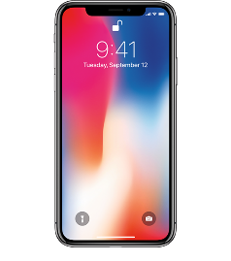 | Tablet
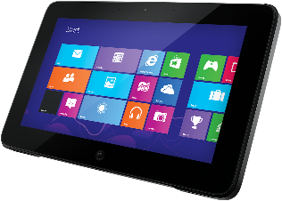 | Phone
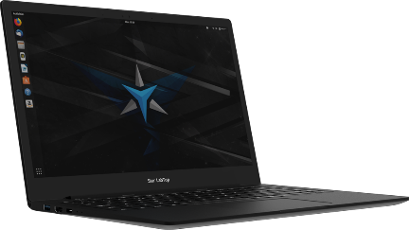 | Laptop
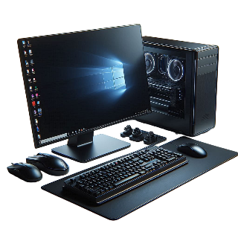 | Computer
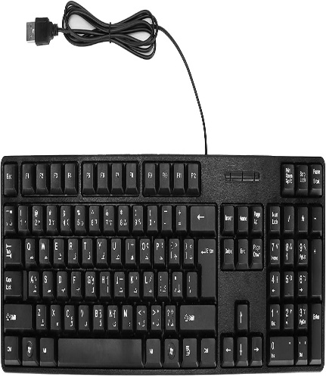 | Keyboard

Q2: Choose the correct answer from the following:
Enter | Mouse
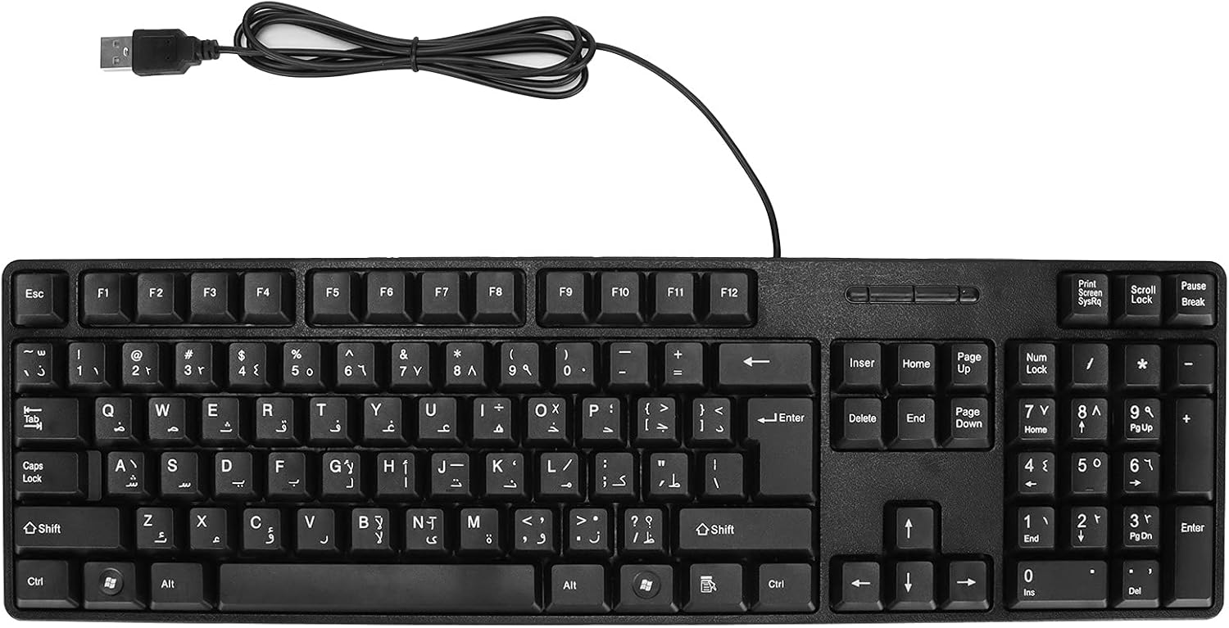 | (……………)  Enter
 | (……………)  Mouse

Q3: Put (✔) or (✘):
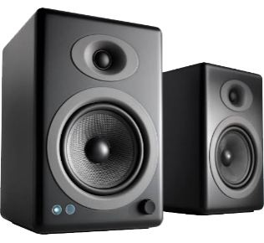 | Enter | (………………………)  ✘
 | Alt | (………………………)  ✔
 | Ctrl | (………………………)  ✔
Good Luck

